Load Balancer Lab
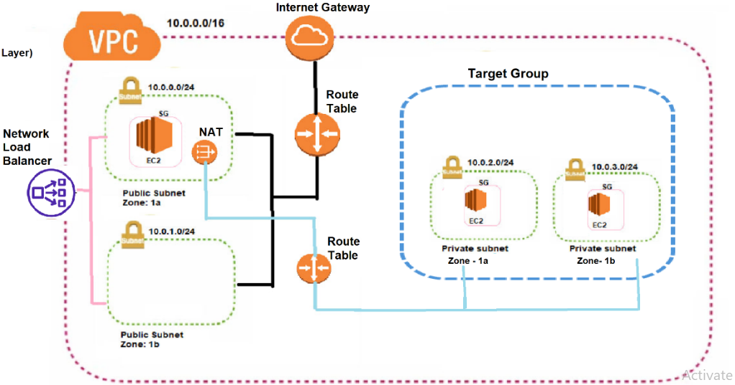

Step 1: Create the VPC and Subnets
First, we'll create the foundational network for our resources.
- Create a VPC: Go to the VPC Console in AWS, click Create VPC, and select VPC only. Give it a name (e.g., My-App-VPC) and an IPv4 CIDR block like 10.0.0.0/16. This provides a large pool of IP addresses for your subnets.
- Create Four Subnets: Create two public subnets and two private subnets, preferably in different Availability Zones (AZs) for high availability.
  - Public Subnet 1: Name it Public-Subnet-A, assign a CIDR block like 10.0.1.0/24, and choose an AZ (e.g., us-east-1a).
  - Public Subnet 2: Name it Public-Subnet-B, assign a CIDR block like 10.0.2.0/24, and choose a second AZ (e.g., us-east-1b).
  - Private Subnet 1: Name it Private-Subnet-A, assign a CIDR block like 10.0.3.0/24, and choose the same AZ as Public-Subnet-A.
  - Private Subnet 2: Name it Private-Subnet-B, assign a CIDR block like 10.0.4.0/24, and choose the same AZ as Public-Subnet-B.
Step 2: Configure Internet Gateway and NAT Gateway
These gateways provide internet access to your resources.
- Create and Attach an Internet Gateway (IGW): Go to Internet Gateways, click Create internet gateway, name it My-IGW, and create it. Select the newly created IGW, choose Actions > Attach to VPC, and attach it to your My-App-VPC.
- Allocate an Elastic IP for NAT Gateway: Navigate to the EC2 Console, go to Elastic IPs, and click Allocate Elastic IP address. This static IP will be used by the NAT Gateway.
- Create a NAT Gateway: In the VPC console, go to NAT Gateways and click Create NAT gateway.
  - Subnet: Select Public-Subnet-A.
  - Elastic IP allocation ID: Select the Elastic IP you just allocated.
  - Connectivity type: Choose Public.
  - Click Create NAT gateway.
Step 3: Configure Route Tables
Route tables direct traffic within your VPC.
- Create a Public Route Table: Go to Route Tables and click Create route table. Name it Public-RT, select your VPC, and create it.
  - Select Public-RT, go to the Routes tab, and click Edit routes.
  - Add a route with Destination 0.0.0.0/0 and Target as your My-IGW.
  - Save the routes.
  - Go to the Subnet associations tab, click Edit subnet associations, and associate Public-Subnet-A and Public-Subnet-B with this route table.
- Create a Private Route Table: Create another route table named Private-RT for your VPC.
  - Select Private-RT, go to the Routes tab, and click Edit routes.
  - Add a route with Destination 0.0.0.0/0 and Target as your NAT Gateway.
  - Save the routes.
  - Associate Private-Subnet-A and Private-Subnet-B with this route table.
Step 4: Create Security Groups
Security groups act as virtual firewalls for your instances.
- bastion-sg: Create a security group for your bastion host.
  - Inbound rules: Add a rule for SSH (Port 22) and set the Source to My IP. This restricts SSH access to only your current IP address.
  - Outbound rules: The default rule allowing all outbound traffic is sufficient, as it will allow the bastion host to SSH into the private instances.
- loadbalancer-sg: Create a security group for your ALB.
  - Inbound rules: Add a rule for HTTP (Port 80) and set the Source to 0.0.0.0/0. This allows the public internet to reach your load balancer.
  - Outbound rules: The default rule allowing all outbound traffic is sufficient.
- application-sg: Create a security group for your private instances.
  - Inbound rules: Add a rule for HTTP (Port 80). For the Source, start typing sg- and select the loadbalancer-sg ID. This ensures only your ALB can send traffic to your application servers.
  - Also, add a rule for SSH (Port 22) with the Source set to the bastion-sg. This allows the bastion host to connect to your private instances.
  - Outbound rules: The default rule allowing all outbound traffic is sufficient.
Step 5: Launch EC2 Instances
Now, launch the three EC2 instances for your bastion host and application servers.
- Launch Public Bastion Host:
  - Choose an Amazon Linux 2 AMI.
  - Select a t2.micro instance type.
  - In Network settings, choose your My-App-VPC, select Public-Subnet-A, and Enable auto-assign public IP.
  - For Security Group, select bastion-sg.
  - Select your key pair (e.g., my-keypair.pem) and launch the instance.
- Launch Two Private Application Servers:
  - Launch two separate instances, naming them App-Server-1 and App-Server-2.
  - Use the same Amazon Linux 2 AMI and t2.micro instance type.
  - In Network settings, place App-Server-1 in Private-Subnet-A and App-Server-2 in Private-Subnet-B. Ensure Auto-assign public IP is disabled for both.
  - For Security Group, select application-sg.
  - Select the same key pair and launch the instances.
Step 6: Create Target Group and Load Balancer
These components will distribute incoming traffic to your application servers.
- Create a Target Group:
  - Go to the EC2 Console -> Target Groups and click Create target group.
  - Choose a target type: Select Instances.
  - Target group name: Name it App-TG.
  - Protocol/Port: Set to HTTP and 80.
  - VPC: Select your My-App-VPC.
  - Health check path: You can leave it as /.
  - Click Next, then register your two private instances (App-Server-1 and App-Server-2) as targets, and finally click Create target group.
- Create an Application Load Balancer:
  - Go to the EC2 Console -> Load Balancers and click Create load balancer.
  - Choose Application Load Balancer.
  - Name: My-App-ALB.
  - Scheme: Internet-facing.
  - IP address type: IPv4.
  - Network mapping: Select your My-App-VPC and map it to both Public-Subnet-A and Public-Subnet-B.
  - Security groups: Select the loadbalancer-sg.
  - Listeners and routing: Create a listener for HTTP on Port 80 and set the default action to forward to your App-TG target group.
  - Review and click Create load balancer.

Step 7: Configure Servers and Test Connectivity

Phase 1: Local Windows to Bastion Host
Open your Windows CMD and run:
1. Connect to Bastion Host
cmd
ssh -i bastion-kp.pem ec2-user@13.63.157.60
- Explanation: Connects you to the public Bastion server using the key downloaded on your Windows machine.
2. Switch to Root User
bash
sudo su -
- Explanation: Elevates your privileges to root so you can manage files and services.
3. (Only if you haven't already) Create and secure the key
(Skip this if bastion-kp.pem is already in your /root/ folder).
bash
vi bastion-kp.pem
# Paste your key, press ESC, type :wq and hit Enter
chmod 400 bastion-kp.pem
- Explanation: vi opens the text editor. chmod 400 makes the file read-only for the owner, which SSH strictly requires.

Phase 2: Configure Private Server 1 (10.0.1.203)
You are currently in the /root/ folder on the Bastion. Run these commands exactly:
1. SSH into Server 1
bash
ssh -i bastion-kp.pem ec2-user@10.0.1.203
- Explanation: Uses the key to connect to Private Server 1. No /home/ needed because the key is in the current folder.
2. Switch to Root
bash
sudo su -
3. Install, Start, and Enable Nginx
bash
yum install nginx -y
systemctl start nginx
systemctl enable nginx
- Explanation: yum install downloads Nginx. systemctl start runs it immediately. systemctl enable ensures it automatically starts if the server reboots (you missed this step earlier!).
4. Create the Web Page (The Easy Way)
bash
echo "<h1>Hello from App Server 1</h1>" > /usr/share/nginx/html/index.html
- Explanation: Instead of using vi (which can cause formatting mistakes), echo prints the text, and > saves it directly into the index.html file.
5. Exit back to Bastion
bash
exit
exit
- Explanation: The first exit leaves root and goes back to ec2-user. The second exit closes the connection to Server 1 and returns you to the Bastion host.

Phase 3: Configure Private Server 2 (10.0.2.152)
You are back on the Bastion host. Run these commands exactly:
1. SSH into Server 2
bash
ssh -i bastion-kp.pem ec2-user@10.0.2.152
- Explanation: Connects to Private Server 2 using the same key.
2. Switch to Root
bash
sudo su -
3. Install, Start, and Enable Nginx
bash
yum install nginx -y
systemctl start nginx
systemctl enable nginx
4. Create the Web Page for Server 2
bash
echo "<h1>Hello from App Server 2</h1>" > /usr/share/nginx/html/index.html
5. Verify Nginx is running
bash
systemctl status nginx
- Explanation: Checks the service. Look for Active: active (running). Press q to exit the status screen.
6. Exit back to Bastion
bash
exit
exit

Phase 4: Final End-to-End Test
- Check Target Group Health:
  - Go to AWS EC2 Console -> Target Groups -> App-TG.
  - Click the Targets tab. Both instances should show Healthy.
  - If they are Unhealthy: Check your application-sg inbound rules. It must allow HTTP (port 80) from the loadbalancer-sg.
- Test the Load Balancer:
  - Go to EC2 Console -> Load Balancers.
  - Copy the DNS name of your ALB (e.g., My-App-ALB-1234567890.eu-north-1.elb.amazonaws.com).
  - Paste it into your web browser and hit Enter.
  - Refresh the page multiple times.

How to Test It (Step-by-Step) DNS name Info
app-lb-1196256789.eu-north-1.elb.amazonaws.com (A Record) Elastic Load Balancer

- Open your web browser (Chrome, Edge, etc.) on your local computer.
- In the address bar, type exactly this (make sure it's http:// and not https://):
text
http://app-lb-1196256789.eu-north-1.elb.amazonaws.com
- Press Enter.
- Refresh the page (F5 or Ctrl+R) multiple times.
What Should Happen?
Because your Load Balancer is distributing traffic between your two private servers, the browser should alternate between showing:
- "Hello from App Server 1"
- "Hello from App Server 2"

❓ Q1: Where is the key pair (bastion-kp.pem) stored right now?
Answer: It is stored on the Public Server (Bastion Host) inside the /root/ directory.
- Why? Because you logged into the Bastion, ran sudo su - (which moved you to the /root/ folder), and then created the file using vi bastion-kp.pem.
❓ Q2: Can I SSH directly from my Windows PC to the Private Servers?
Answer: No.
- Why? Private servers do not have public IP addresses, and their Security Group (application-sg) only allows SSH traffic from the Bastion Host's Security Group. They are hidden from the internet for security.
❓ Q3: How do I connect from the Bastion Host to Private Server 1?
Answer: Run this exact command from the Bastion:
bash
ssh -i bastion-kp.pem ec2-user@10.0.1.203
- Explanation: -i bastion-kp.pem tells SSH to use the key sitting in the current folder. ec2-user is the default username. 10.0.1.203 is the private IP of Server 1.
❓ Q4: How do I connect from the Bastion Host to Private Server 2?
Answer: Run this exact command from the Bastion:
bash
ssh -i bastion-kp.pem ec2-user@10.0.2.152
- Explanation: Same logic as above, but using the private IP of Server 2 (10.0.2.152).
❓ Q5: Why did I get the "UNPROTECTED PRIVATE KEY FILE" error earlier?
Answer: Because the key file had permissions of 0644 (readable by everyone).
- How to fix it: Run chmod 400 bastion-kp.pem. This makes the file read-only for the owner only, which SSH strictly requires to accept the key.
❓ Q6: Do I need to copy the key onto the Private Servers?
Answer: No.
- Why? You only need the key to get inside the private server. Once you are logged in, you don't need the key anymore. Copying it to the private server would be a security risk.
❓ Q7: What is the complete connection flow (The "Jump")?
Answer:
- Windows PC (has the original key)
- ⬇️ SSH
- Public Bastion Host (key is copied here)
- ⬇️ SSH
- Private Server 1 or Private Server 2
❓ Q8: What is the role of the Bastion Host in this process?
Answer: It acts as a "Jump Server." It is the only door into your private network. You enter through the public door (Bastion), and from there, you can jump to the private servers inside.
❓ Q9: What happens if I terminate the Bastion Host?
Answer: You will lose the key stored in the /root/ folder, and you will lose your entry point into the private servers.
- Solution: You would need to launch a new Bastion Host, upload the key again from your Windows PC using scp, run chmod 400, and then you can connect again.
❓ Q10: What was the exact missing command from your earlier logs?
Answer: systemctl enable nginx
- Why is it important? systemctl start nginx only starts the web server right now. systemctl enable nginx ensures that if the private server reboots, Nginx will automatically start back up.

Delete in this exact order:
1. Delete the Application Load Balancer (ALB)
Go to EC2 -> Load Balancers. Select your ALB and delete it. (This stops all incoming traffic).
2. Delete the Target Group
Go to EC2 -> Target Groups. Select your target group and delete it. (The ALB is no longer using it).
3. Terminate all EC2 Instances
Go to EC2 -> Instances. Select your Bastion Host, App-Server-1, and App-Server-2. Terminate them. (Wait until they show "Terminated" before moving to the next step).
4. Delete the NAT Gateway
Go to VPC -> NAT Gateways. Select your NAT Gateway and delete it. (Wait until it shows "Deleted" — this takes a few minutes).
5. Release the Elastic IP (EIP)
Go to EC2 -> Elastic IPs. Select the IP that was attached to your NAT Gateway. Release it. (If you don't release it, AWS will charge you).
6. Delete the Security Groups
Go to VPC -> Security Groups. Delete bastion-sg, loadbalancer-sg, and application-sg. (You cannot delete the "default" security group).
7. Delete the Route Tables
Go to VPC -> Route Tables.
- Select Public-RT, go to Subnet Associations, and disassociate all subnets. Click Save.
- Select Private-RT, go to Subnet Associations, and disassociate all subnets. Click Save.
- Now select both route tables and delete them. (You cannot delete the "Main" route table).
8. Detach and Delete the Internet Gateway (IGW)
Go to VPC -> Internet Gateways. Select your IGW. Click Actions -> Detach from VPC. Once detached, click Actions -> Delete Internet Gateway.
9. Delete the Subnets
Go to VPC -> Subnets. Select Public-Subnet-A, Public-Subnet-B, Private-Subnet-A, and Private-Subnet-B. Delete them.
10. Delete the VPC
Go to VPC -> Your VPCs. Select your custom VPC and delete it.

